**Assignment**

**Machine Learning With Python**

**Name – Ashwani Dhankhar**

**Reg. No. – 180612s005**

1. **What is Machine Learning?**

Machine learning is an application of artificial intelligence (AI) that provides systems the ability to automatically learn and improve from experience without being explicitly programmed. **Machine learning focuses on the development of computer programs** that can access data and use it learn for themselves.

1. **What are the different types of Machine Learning?**

**There are 3 types of Machine Learning-**

* **Supervised Learning – Used when the information used to train is labelled to predict future events.**
* **Unsupervised Learning -** Used when the information used to train is neither classified nor labelled.
* **Reinforcement Learning – It** is a learning method that interacts with its environment by producing actions and discovers errors or rewards.

1. **Explain Classification and Regression.**

Regression and classification are categorized under supervised machine learning.

Both share the same concept of utilizing known datasets (referred to as training datasets) to make predictions.

**Regression:**

In machine learning, regression algorithms attempt to estimate the mapping function (f) from the input variables (x) to numerical or continuous output variables (y).

In this case, y is a real value, which can be an integer or a floating point value. Therefore, regression prediction problems are usually quantities or sizes.

**Classification:**

Whereas, classification algorithms attempt to estimate the mapping function (f) from the input variables (x) to discrete or categorical output variables (y).

In this case, y is a category that the mapping function predicts. If provided with a single or several input variables, a classification model will attempt to predict the value of a single or several conclusions.

1. **What do you understand by Precision and Recall?**

**Precision**

Percentage of positive instances out of the *total predicted positive* instances. Here denominator is the model prediction done as positive from the whole given dataset.

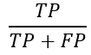

# ****Recall****

Percentage of positive instances out of the total actual positiveinstances. Therefore denominator (TP + FN) here is the actual number of positive instances present in the dataset.

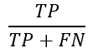

**5. Explain false negative, false positive, true negative and true positive with a simple example.**

One fine morning, Jack got a phone call. It was a stranger on the line. Jack, still sipping his freshly brewed morning coffee, was barely in a position to understand what was coming for him. The stranger said, “Congratulations Jack! You have won a lottery of $10 Million! I just need you to provide me your bank account details, and the money will be deposited in your bank account right way…”

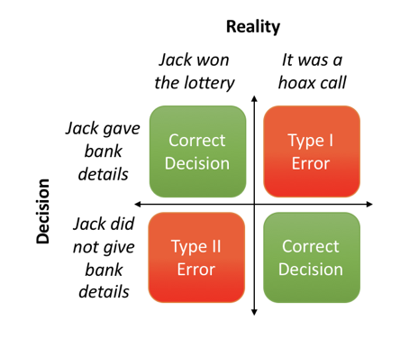

False Positive

True Positive

True Negative

False Negative